Statistical Analysis and Predictive Modeling using R
Yuva Intern – Week 3 Task
Dataset: Air Quality Missing Data
Name: Mahesh
Tools: R, RStudio

1. Introduction
This report documents the Week 3 statistical analysis and predictive modeling performed in R on the Air Quality Missing Data dataset. The analysis extends the earlier cleaning and visualization work by applying hypothesis testing, regression modeling, predictive evaluation, cross-validation, and regression diagnostics.

2. Dataset and Variables
The cleaned dataset contains 153 observations. The original variables are Date, Ozone, Solar, Wind, and Temp. Missing Ozone and Solar values were previously handled using median imputation.
- Target variable: Ozone
- Predictors: Temperature (Temp), Wind, and Solar
- Date was retained but was not used as a predictor in the regression model.

3. Research Question and Hypotheses
Research question: Is there a statistically significant linear relationship between Ozone concentration and Temperature, and can Ozone be predicted from Temperature, Wind, and Solar?
- H0: There is no linear correlation between Ozone and Temperature (population correlation = 0).
- H1: There is a linear correlation between Ozone and Temperature (population correlation ≠ 0).
For the regression model, the overall null hypothesis is that the predictor coefficients are jointly zero, while the alternative is that at least one predictor contributes to explaining Ozone variation.

4. Exploratory Statistical Analysis
The cleaned data were examined using summary statistics and correlation analysis. The Pearson correlation between Ozone and Temperature was 0.6008328, indicating a positive linear association in this dataset.
- Ozone: mean 39.56; median 31.5; minimum 1; maximum 168.
- Solar: mean 186.8; median 205; minimum 7; maximum 334.
- Wind: mean 9.958; median 9.7; minimum 1.7; maximum 20.7.
- Temperature: mean 77.88; median 79; minimum 56; maximum 97.

5. Hypothesis Testing – Pearson Correlation
cor_test <- cor.test(
Air_Quality_Cleaned$Ozone,
Air_Quality_Cleaned$Temp,
method = "pearson"
)
print(cor_test)
Result: t = 9.2362, df = 151, p-value < 2.2e-16, Pearson correlation = 0.6008328, with a 95% confidence interval from 0.4887518 to 0.6934026.
Interpretation: The p-value is far below 0.05, providing evidence against the null hypothesis of zero linear correlation. The estimated correlation is positive. This indicates an association between Temperature and Ozone in the dataset; it does not establish causation.

6. Normality Analysis
ozone_normality <- shapiro.test(
Air_Quality_Cleaned$Ozone
)
print(ozone_normality)
The Shapiro-Wilk test for Ozone produced W = 0.83598 and p-value = 8.439e-12. This indicates that Ozone was not normally distributed under the test.

7. Multiple Linear Regression Model
model <- lm(
Ozone ~ Temp + Wind + Solar,
data = Air_Quality_Cleaned
)
print(summary(model))
Estimated model: Ozone = -39.35406 + 1.23295(Temp) - 2.78709(Wind) + 0.05696(Solar)
- Temperature coefficient = 1.23295, p = 3.97e-08.
- Wind coefficient = -2.78709, p = 1.36e-06.
- Solar coefficient = 0.05696, p = 0.00586.
- Residual standard error = 21.32 on 149 degrees of freedom.
- Multiple R-squared = 0.4721; Adjusted R-squared = 0.4615.
- Overall F-statistic = 44.42 on 3 and 149 degrees of freedom, p < 2.2e-16.
Interpretation: In the fitted model, Temperature has a positive estimated association with Ozone, Wind has a negative estimated association, and Solar has a positive estimated association, holding the other predictors constant. The model explains about 47.21% of observed Ozone variation in the full cleaned dataset. These are associations, not causal effects.

8. Train-Test Split and Prediction
set.seed(123)
train_index <- sample(
1:nrow(Air_Quality_Cleaned),
size = 0.8 * nrow(Air_Quality_Cleaned)
)
train_data <- Air_Quality_Cleaned[train_index, ]
test_data <- Air_Quality_Cleaned[-train_index, ]
An 80/20 split was used with a fixed random seed. The training set contained 122 observations and the test set contained 31 observations.
train_model <- lm(
Ozone ~ Temp + Wind + Solar,
data = train_data
)
predictions <- predict(
train_model,
newdata = test_data
)

9. Model Performance
The held-out test set was evaluated using RMSE, MAE, and R-squared.
- Test RMSE = 20.29155
- Test MAE = 14.38105
- Test R-squared = 0.522513 (approximately 52.25%).
Interpretation: The test R-squared indicates that approximately 52.25% of the variation in Ozone in the held-out test data is explained by the model. RMSE and MAE measure prediction error on the Ozone scale; lower values indicate smaller errors.

10. 5-Fold Cross-Validation
set.seed(123)
K <- 5
folds <- sample(rep(1:K, length.out = nrow(train_data)))
cv_rmse <- numeric(K)
for (k in 1:K) {
cv_train <- train_data[folds != k, ]
cv_valid <- train_data[folds == k, ]
cv_model <- lm(Ozone ~ Temp + Wind + Solar, data = cv_train)
cv_pred <- predict(cv_model, newdata = cv_valid)
cv_rmse[k] <- sqrt(mean((cv_valid$Ozone - cv_pred)^2))
}
print(cv_rmse)
print(mean(cv_rmse))
The five validation RMSE values were 14.60028, 29.22272, 22.93368, 17.22473, and 23.26054. Average 5-fold CV RMSE = 21.44839.
Interpretation: Cross-validation provides an additional estimate of predictive error across different validation folds. The variation among fold RMSE values shows that prediction error changes across subsets of the training data.

11. Regression Diagnostics
par(mfrow = c(2, 2))
plot(train_model)
par(mfrow = c(1, 1))
The standard four diagnostic plots were examined: Residuals vs Fitted, Normal Q-Q, Scale-Location, and Residuals vs Leverage.
- Residuals vs Fitted: some curvature/non-linearity and a noticeable unusual observation around observation 117.
- Normal Q-Q: departures from the reference line, particularly in the upper tail.
- Scale-Location: residual spread suggested that constant variance may not fully hold.
- Residuals vs Leverage: observations including 117, 99, and 25 appeared worthy of further investigation. The plot alone does not establish that they are definitively influential.

12. Normality Test of Regression Residuals
residual_test <- shapiro.test(
residuals(train_model)
)
print(residual_test)
Result: W = 0.90359, p-value = 2.5e-07.
Interpretation: The residuals were not normally distributed at conventional significance levels. This is consistent with the departure from the reference line observed in the Normal Q-Q plot.

13. Overall Interpretation
The analysis found a statistically significant positive linear association between Temperature and Ozone. The multiple regression model also showed statistically significant estimated coefficients for Temperature, Wind, and Solar. Test-set performance was RMSE = 20.29155, MAE = 14.38105, and R-squared = 0.522513. Five-fold cross-validation produced an average RMSE of 21.44839.
The diagnostic analysis identified departures from standard linear-regression assumptions, including non-normal residuals, possible non-linearity, and possible non-constant variance. Therefore, this should be treated as an initial predictive model rather than a final optimized model.

14. Strengths of the Analysis
- Reproducible random seed used for train-test split and cross-validation.
- Both held-out test performance and cross-validation were used.
- Multiple predictors were considered simultaneously.
- Standard regression diagnostic plots were examined.
- Residual normality was tested in addition to visual diagnostics.
- Association was distinguished from causation.

15. Potential Improvements
- Investigate unusual observations such as observation 117 and other potentially influential points using formal influence diagnostics.
- Consider appropriate transformations of Ozone or predictors if justified by further analysis.
- Explore nonlinear relationships, such as polynomial terms or flexible regression methods, if supported by the data.
- Examine heteroscedasticity with a formal test and consider robust standard errors if appropriate.
- Compare alternative predictive models using the same cross-validation procedure.
- Use repeated cross-validation or a larger dataset, if available, for more stable performance estimates.
- Keep a separate final test set when comparing multiple candidate models to reduce test-set overfitting.

16. Conclusion
This Week 3 project applied hypothesis testing, exploratory statistical analysis, multiple linear regression, train-test evaluation, five-fold cross-validation, and regression diagnostics to an air-quality dataset. The results demonstrated a statistically significant relationship between Temperature and Ozone and showed statistically significant predictor coefficients in the fitted regression model. Predictive evaluation provided measurable test-set performance, while diagnostics highlighted assumptions that should be addressed in future model improvements.

17. Reproducibility
The analysis was performed in R/RStudio. The main analysis script is named week3_statistical_modeling.R. A fixed seed of 123 was used for the train-test split and five-fold cross-validation.

18. Regression Diagnostic Plots
The following diagnostic plots were generated in R from the training regression model. They provide visual evidence for checking linearity, residual normality, constant variance, and potentially influential observations.
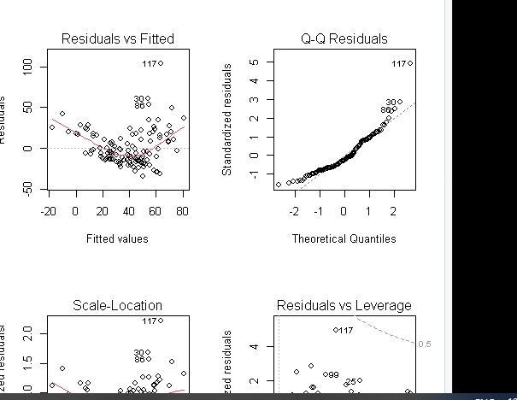
Figure 1. Regression diagnostic plots: Residuals vs Fitted, Normal Q-Q, Scale-Location, and Residuals vs Leverage.

18. Regression Diagnostic Plots
The complete four-panel diagnostic figure generated from the training regression model is shown below. The plots assess residual patterns, residual normality, variance stability, and potentially influential observations.
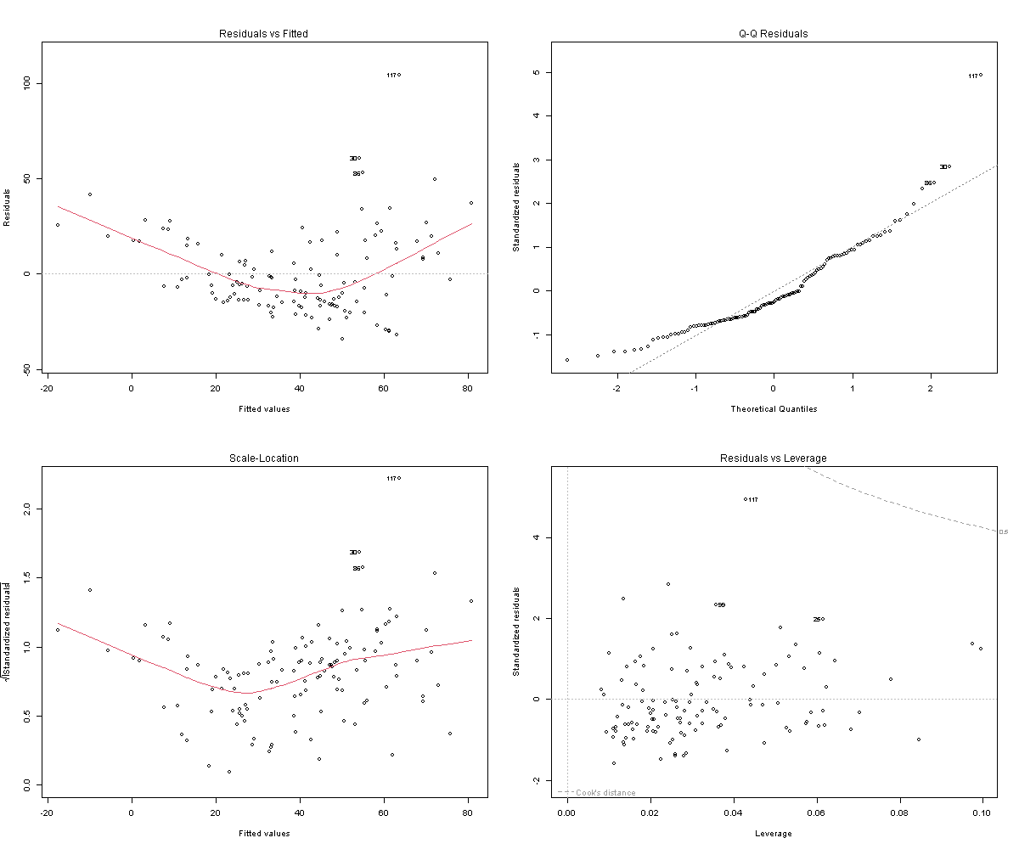
Figure 1. Complete regression diagnostic plots: Residuals vs Fitted, Normal Q-Q, Scale-Location, and Residuals vs Leverage.

